Preference Modelling

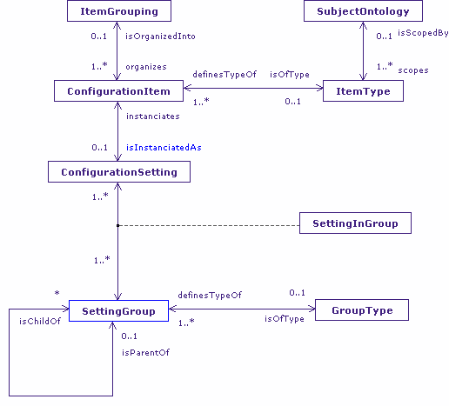

User Preference
User preference, in the general sense, is personal intervention in the choice of alternative outcomes for a given activity. That choice may be guided by personal capability, or by the context of that personal interaction, but it remains an arbitrary personal selection. Those choices may not appear sensible to others, nor may it always be possible to satisfy what could be highly contradictory requests.
Within the narrow confines of computer user interfaces, user preference manifests itself in the choice of configuration settings, possibly over a diverse range of subject matter; the Windows control panel is a very good example of this, with the menu covering everything from “accessibility” options, to user account management, to printer driver installation.
Capability, Profile, and Preference
The distinction I would make between capability and profile on the one hand, and preference on the other, is similar to the definition of an abstract user interface. Just as an abstract user interface separates what is to be represented by an interface from the manner of its representation, so I choose to separate the model of the user’s physical and cognitive capabilities from the user’s arbitrary personal intervention into how those models are applied in construction of the user interface.
The effect of that distinction on existing user profiling techniques is illuminating. Taking the Access For All model used by Voula (as used by Frank’s XML examples), it is difficult to see anything other than preferences expressed in the model. If it wasn’t for the comment at the top of the files e.g. in profile B, “Blind user using screen reader and braille output device in a classroom :: Brian”, it would be difficult to identify specific capabilities at all. In profile B, is the need for a screen reader the result of visual impairment or cognitive impairment; or is it simply the need for a low attention interface, say reading emails whilst driving? We know it is because of visual impairment only because of the comment. Other settings such as the request for a Braille display also suggest visual impairment, but if Brian was one of the many blind people who do not read Braille, we would not even get that hint.
Does it matter that Brian’s profile is purely preference based? After all, if it gives sufficient information to correctly configure a system to Brian’s personal needs, surely that is all that is required? I would argue that in the general case, the answer is a resounding yes, it does matter. It matters because user preferences as described in Access For All are very solution-dependent, and based on a detailed working knowledge of existing tools and techniques. The moment a new interaction modality, or a new commercial tool, becomes available then every single user profile is out of date. Also, the people who create such profiles may be very professional but they are not omnipotent, and it is unreasonable to expect them to know of every potential accessibility solution for their user, and know it in sufficient detail to configure it in the profile. However, if the profile additionally described how well Brian can see, how well he can hear, or indeed how well he can handle nested menus, an informed decision can be made as to how to support Brian at any time, not only for a named and specific subset of potential solutions. Knowing the preferred settings for particular tools is undoubtedly useful, but is of much less importance than knowing why you need those settings. I don’t particularly like biblical quotations, but “Give a man a fish and he will eat for a day, teach him to fish and he will eat for a lifetime”, does have resonance in this case.
The Preference Model
Given the decision to fully separate capability from preference, it is then necessary to ask where preference modelling lies within the overall Carnforth user interface model. The answer must be: wherever the user needs to express their preference for particular configuration settings. So: in user, device, and environment capabilities; in direct selection and configuration of interaction modalities; and potentially in the selection between alternative computer programs. However, it may well be, depending upon context, that not all configuration settings need to be user configurable. The way I resolve this within Carnforth is through a context-independent abstract model of preference, and use of Shlaer-Mellor bridges to map between preference and settings scattered throughout the different problem domains that make up the complete Carnforth UI Model.
The Preference Model is described below, but it is the bridges that are of most importance. I already use the technique in the CISNA model to map between nodes in the navigation layer and nouns in the semantics layer, providing a many-to-many mapping between the two related concepts. The same approach is taken here, with ConfigurationSetting objects in the Preference Model mapping to, say, the Setting object in the Profile Model. Note however, that we can bridge between ConfigurationSetting and any object within Carnforth, all this is requires is the construction of a bridge between them. So, for example, if it was considered appropriate for the use to manage definition of categories of capability properties, then we could equally map between ConfigurationSetting and the Property object in the Capability Model. Overall, this provides a very powerful and flexible approach to the management and scoping of user preference. If we consider those bridges to “belong” to users, rather than to the “system”, then it is possible to describe different User Preference Sets for different categories of user. It becomes possible to define different profiles for administrators and standard users, for novices and for experts, fro mobile users and desktop users etc. The detailed ability to express preference for the manner of expression of the user interface becomes context sensitive in the same way as capability profiles.
Configuration Items
The model of Preference centres on Configuration Items objects. Those items to be managed by the user are instantiated as ConfigurationSettings, and grouped to make cognitive sense to the user. Such Setting Groups may well directly reflect groupings found in the target domains, for example SettingGroup in the Profile Model, but not necessarily. It may be that not settings in a Profile SettingGroup should be offered to particular users for configuration, for example in a split between novice and expert user; in this case it may be that the settings in the Preference Model SettingGroup are a subset of those provided in the Profile version.
Note that the Preference Model is quite different from the Profile Model (and indeed all other models to which it is bridged) in that the Preference Model is an organization of content, not container of values; the ConfigurationSetting in the Preference Model is a reference to a value, it does not hold any value.
External Influences
One of the objects that appear within the Profile Model is ExternalInfluence. Externalnfluences affect the choice of active SettingGroups and can trigger Actions that update functionally dependent settings. One such ExternalInfluence would most certainly be changes in user preference. Within Carnforth, this can be catered for, again, by the use of bridging, to bridge between ConfiguratonSetting, or SettingGroup objects and ExternalInfluence in the Profile Model. The ActionTriggers in the ProfileModel may then drive changes in settings, and by implication, setting groups.
Contribution to knowledge
The Preference Model presented here, and its generic abstract form improve on existing profiling approaches such as Access For All, in providing a clear separation of concerns between the description of a user’s capabilities, and specific preferences for settings and tools.
By providing an abstract model of preference, it becomes possible to use bridges to map to any settings of interest throughout a user interface (and indeed to application settings where appropriate). Since such bridges “belong” to the preference model, this approach to preference modelling implicitly allows for the creation of preference sets unique to specialised groups of users: administrator and user, novice and expert, and so on, whilst retaining a single simple meta-model of preference.
The Preference Model, as with the CISNA< Capability, and Action Language models, also benefits from my transaction approach to adaptation, allowing us to say “Fred is like Jim except...”.

